

**DATA WAREHOUSING & BUSINESS INTELLIGENCE**

**(INFO 7290)**

**SEC 01 SPRING 2020 (VTL-2-OL)**

**Team 07: DeDupe**

**Group Members:**

Priyanka Donta

Terance Barretto

Pratik Chavan

Pratik Kadam

**VERSION HISTORY:**

|  |  |  |  |
| --- | --- | --- | --- |
| **Date** | **Worked By** | **Topics Covered** | **Version** |
| 3/15 | All members | Initial Proposal with Data Description, Task Flow, Project Objectives, Model | 0.1 |
| 3/18 | Pratik Kadam | Collect links for  Provider Outpatient Data  Provider Inpatient Data | 0.2 |
| 3/18 | Priyanka Donta | Collect Census Datalink | 0.2 |
| 3/19 | Pratik Chavan | Understand the business objective | 0.2 |
| 3/21 | Terance Barretto | Additional links to Census data | 0.3 |
| 3/22 | All Team members | Finalize on the Project Proposal Draft | 0.3 |
| 3/25 | Pratik Chavan | Inpatient Data Description | 0.4 |
| 3/25 | Pratik Kadam | Outpatient Data Description | 0.4 |
| 3/28 | Priyanka Donta | Medicare Hospital Cost Data Description | 0.4 |
| 3/29 | Terance Barretto | Medicare Hospital Cost Data Description | 0.4 |
| 4/2 | Terance Barretto | Data profiling for Medicare Hospital Cost Data | 0.5 |
| 4/4 | Pratik Kadam | Data profiling for Medicare Inpatient Data | 0.5 |
| 4/4 | Pratik Chavan | Data profiling for Medicare Outpatient Data | 0.5 |
| 4/5 | Terance Barretto | Data profiling for Census Data | 0.5 |
| 4/5 | Priyanka Donta | High Level view of Data Flow | 0.6 |
| 4/6 | Pratik Chavan | EDW Data Integration Diagram | 0.6 |
| 4/7 | Pratik Kadam | ER Diagram | 0.6 |
| 4/8 | All team members | Create the design document | 0.6 |
| 4/11 | All team members | Discuss and finalize the project flow | 0.6 |
| 4/12 | Pratik Kadam | Create users on Azure for Team | 0.7 |
| 4/12 | Priyanka Donta | Understand Power BI | 0.7 |
| 4/12 | Terance Barretto | Create Lookup tables for ... | 0.7 |
| 4/13 | Pratik Chavan  Pratik Kadam | Create SQL server database on Azure | 0.7 |
| 4/14 | Pratik Chavan  Pratik Kadam | Create SSIS data flow for Source, Staging and Archive tables | 0.7 |
| 4/15 - 4/23 | Pratik Chavan  Pratik Kadam  Priyanka Donta  Terance Barretto | updated the document as the changes were made. | 1 |

1. Objective
2. Tools
3. Overview of the data model
4. ER diagram
5. Implementation
6. Observations
7. Results / Visualization
8. Future Scope

# Objective/ Scope of Document

Medicare is the most important sector for any government to gauge their performance. However, it can be tedious for a government official to see all the metrics at a glance like cost, revenue, expenses etc. Our objective for this project would be to create a tool which will enable the user to slice and dice this data as per convenience. This includes creating dashboards and a cube(yet to decide based on further scope of project). Upon completion of the project, following objectives are expected to be achieved:

* To analyze the Provider’s covered charges, Total payments to all Providers and Medicare payments at hospital level and also based on the type of clinical condition (diagnosis) and the procedure furnished by the hospital during the stay of the inpatients
* To analyze the Provider’s submitted charges, Medicare and Beneficiaries’ payments to the provider at hospital level and also based on Medicare’s APC (Ambulatory Payment Classification) description for outpatients
* To connect the hospital dataset with census data based on City and State level and finding if there is sufficient availability of Hospitals for the people living in that area
* As an individual interested in knowing the cost of setting up a hospital. I want to know the cost break-up to set-up a new hospital in a given location in the US.
* As an investor I want to know if there is a difference in the cost and the break-up of cost for a given provider. I would be interested in knowing the difference in cost for the different healthcare provided by a given hopital.
* An exhaustive data warehouse, easily available, clean and understood
* Dashboard, with easily interpretable information and interactive
* An OLAP cube, with slicing and dicing by geography, type of hospitals, time, titles etc.
* Create a sentiment on hospital financials on their performance state wise to gauge performances

**Stakeholders:**

Anyone who wants to understand the Healthcare performance at a glance and make decisions regarding the Hospitals.

# Tools

1. SQL Server Integration Services (SSIS)
2. SQL Server Management Studio (SSMS)
3. Azure SQL Server
4. Azure SQL Database
5. Azure DevOps
6. Power BI Desktop

# Overview of the data model

# 

# 

# ER diagram

# 

# 

# 

# Dataset Description

|  |  |  |  |  |
| --- | --- | --- | --- | --- |
| **Inpatient Prospective Payment System (IPPS) Provider Summary for All Diagnosis-Related Groups (DRG) - FY2017** | | | | |
|  |  |  |  |  |
| **ID** | **Column** | **Data type** | **Definition** | **Data Size** |
| 1 | DRG Definition | Text | The code and description identifying the MS-DRG. 3 digit code followed by the description | 80 Bytes |
| 2 | s | Text | The CMS Certification Number (CCN) assigned to the Medicare certified hospital facility. 5-6 digit code | 80 Bytes |
| 3 | Provider Name | Text | The name of the provider. | 80 Bytes |
| 4 | Provider Street Address | Text | The provider’s street address. | 80 Bytes |
| 5 | Provider City | Text | The city where the provider is located. | 80 Bytes |
| 6 | Provider State | Text | The state where the provider is located. | 80 Bytes |
| 7 | Provider Zip Code | Text | The provider’s zip code. 4-5 digit code | 80 Bytes |
| 8 | Hospital Referral Region (HRR) Description | Text | The Hospital Referral Region (HRR) where the provider is located. | 80 Bytes |
| 9 | Total Discharges | Number | The number of discharges billed by the provider for inpatient hospital services. | 80 Bytes |
| 10 | Average Covered Charges | Number | The provider's average charge for services covered by Medicare for all discharges in the MS-DRG. | 80 Bytes |
| 11 | Average Total Payments | Number | The average total payments to all providers for the MS-DRG | 80 Bytes |
| 12 | Average Medicare Payments | Number | The average amount that Medicare pays to the provider for Medicare's share of the MS-DRG. | 80 Bytes |

|  |  |  |
| --- | --- | --- |
| Staging.ProviderIPPS |  |  |
|  |  |  |
| **ID** | **API Field Name** | **Data type** |
| 1 | RecordYear | int |
| 2 | DRGDefinition | varchar(120) |
| 3 | DRGCode | varchar(5) |
| 4 | DRGDescription | varchar(100) |
| 5 | ProviderID | varchar(6) |
| 6 | ProviderName | varchar(75) |
| 7 | ProviderStreetAddress | varchar(100) |
| 8 | ProviderCity | varchar(50) |
| 9 | ProviderState | varchar(2) |
| 10 | ProviderZipCode | varchar(5) |
| 11 | HospitalReferralRegion | varchar(50) |
| 12 | TotalDischarges | int |
| 13 | AverageCoveredCharges | float |
| 14 | AverageTotalPayments | float |
| 15 | AverageMedicarePayments | float |
| 16 | LoadDate | datetime |
| 17 | DRGCodeLK | int |
| 18 | ProviderIDLK | int |

|  |  |  |
| --- | --- | --- |
| **SQL for Staging** |  |  |
|  |  |  |
| **Staging.ProviderIPPS** |  |  |
|  |  |  |
| **ID** | **API Field Name** | **Data type** |
| 1 | drg_definition | nvarchar(100) |
| 2 | provider_id | int |
| 3 | provider_name | nvarchar(50) |
| 4 | provider_street_address | nvarchar(50) |
| 5 | provider_city | nvarchar(50) |
| 6 | provider_state | nvarchar(50) |
| 7 | provider_zip_code | int |
| 8 | hospital_referral_region | nvarchar(50) |
| 9 | total_discharges | int |
| 10 | average covered charges | float |
| 11 | average total payments | float |
| 12 | average_medicare_payments | float |
| 13 |  |  |

|  |  |  |  |  |
| --- | --- | --- | --- | --- |
| **EDW Schema/Integration Layer** |  |  |  |  |
|  |  |  |  |  |
| **Source Table** | **Source Field** | **Destination Table** | **Destination Field** | **Lookup Logic** |
| staging.ProviderIPPS | RecordYear | reporting.ProviderIPPS | RecordYear | Copied as it is |
| staging.ProviderIPPS | DRGDefinition | reporting.ProviderIPPS | ProviderID | drg_code lookup against lookup_DRGCodes |
| staging.ProviderIPPS | DRGCode | reporting.ProviderIPPS | ProviderName | Copied as it is |
| staging.ProviderIPPS | DRGDescription | reporting.ProviderIPPS | ProviderTypeOfControlCode | Copied as it is |
| staging.ProviderIPPS | ProviderID | reporting.ProviderIPPS | ProviderTypeCode | provider_id lookup against lookup_provider |
| staging.ProviderIPPS | ProviderName | reporting.ProviderIPPS | ProviderCity | Copied as it is |
| staging.ProviderIPPS | ProviderStreetAddress | reporting.ProviderIPPS | ProviderCounty | Copied as it is |
| staging.ProviderIPPS | ProviderCity | reporting.ProviderIPPS | ProviderState | Copied as it is |
| staging.ProviderIPPS | ProviderState | reporting.ProviderIPPS | HospitalReferralRegion | Copied as it is |
| staging.ProviderIPPS | ProviderZipCode | reporting.ProviderIPPS | DRGCode | Copied as it is |
| staging.ProviderIPPS | HospitalReferralRegion | reporting.ProviderIPPS | DRGDescription | Copied as it is |
| staging.ProviderIPPS | TotalDischarges | reporting.ProviderIPPS | TotalDischarges | Copied as it is |
| staging.ProviderIPPS | AverageCoveredCharges | reporting.ProviderIPPS | AverageCoveredCharges | Copied as it is |
| staging.ProviderIPPS | AverageTotalPayments | reporting.ProviderIPPS | AverageTotalPayments | Copied as it is |
| staging.ProviderIPPS | AverageMedicarePayments | reporting.ProviderIPPS | AverageMedicarePayments | Copied as it is |
| staging.ProviderIPPS | LoadDate | reporting.ProviderIPPS | LoadDate | Copied as it is |
| staging.ProviderIPPS | DRGCodeLK | reporting.ProviderIPPS |  |  |
| staging.ProviderIPPS | ProviderIDLK | reporting.ProviderIPPS |  |  |

|  |  |  |  |  |
| --- | --- | --- | --- | --- |
| **Provider Outpatient Hospital Charge Data by APC, CY2017** | | | | |
|  |  |  |  |  |
| **SOURCE** | |  |  |  |
|  |  |  |  |  |
| **ID** | **Column** | **Data type** | **Definition** | **Data Size** |
| 1 | Provider_ID | Text | The CMS Certification Number (CCN) of the provider billing for outpatient hospital services. 5-6 digit code | 80 Bytes |
| 2 | Provider_Name | Text | The name of the provider. | 80 Bytes |
| 3 | Provider_Street_Address | Text | The street address in which the provider is physically located. | 80 Bytes |
| 4 | Provider_City | Text | The city in which the provider is physically located. | 80 Bytes |
| 5 | Provider_State | Text | The state in which the provider is physically located. | 80 Bytes |
| 6 | Provider_Zip_Code | Text | The zip code in which the provider is physically located. 4-5 digit code | 80 Bytes |
| 7 | Provider_HRR | Text | The Hospital Referral Region (HRR) in which the provider is physically located. | 80 Bytes |
| 8 | APC | Text | The comprehensive APC code. 4 Digit code | 80 Bytes |
| 9 | APC_Desc | Text | The description of the APC Code. | 80 Bytes |
| 10 | Beneficiaries | Number | The number of Medicare fee-for-service beneficiaries receiving outpatient hospital services. | 80 Bytes |
| 11 | CAPC_Services | Number | The number of primary HCPCS services billed by the provider for outpatient hospital services. | 80 Bytes |
| 12 | Average_Total_Submitted_Charges | Number | The provider's average estimated submitted charge for services covered by Medicare for the APC. | 80 Bytes |
| 13 | Average_Medicare_Allowed_Amount | Number | The average of total regular payments the provider receives for the APC. | 80 Bytes |
| 14 | Average_Medicare_Payment_Amount | Number | The average of total regular payments the provider receives directly from Medicare | 80 Bytes |
| 15 | Outlier_Services | Number | The number of comprehensive APC services with outlier payments. | 80 Bytes |
| 16 | Average_Medicare_Outlier_Amount | Number | The average of outlier payments the provider receives directly from Medicare. | 80 Bytes |

|  |  |  |
| --- | --- | --- |
| **staging.ProviderOHCD** |  |  |
|  |  |  |
| **ID** | **API Field Name** | **Data type** |
| 1 | RecordYear | int |
| 2 | APCCode | varchar(5) |
| 3 | APCDescription | varchar(100) |
| 4 | ProviderID | varchar(6) |
| 5 | ProviderName | varchar(75) |
| 6 | ProviderStreetAddress | varchar(100) |
| 7 | ProviderCity | varchar(50) |
| 8 | ProviderState | varchar(2) |
| 9 | ProviderZipCode | varchar(5) |
| 10 | HospitalReferralRegion | varchar(50) |
| 11 | BeneficiariesCount | int |
| 12 | ComprehensiveAPCServicesCount | int |
| 13 | AverageEstimatedTotalSubmittedCharges | float |
| 14 | AverageMedicareAllowedAmount | float |
| 15 | AverageMedicarePaymentAmount | float |
| 16 | OutlierComprehensiveAPCServices | int |
| 17 | AverageMedicareOutlierAmount | float |
| 18 | LoadDate | datetime |
| 19 | ProviderIDLK | int |

|  |  |  |  |  |
| --- | --- | --- | --- | --- |
| **EDW Schema/Integration Layer** |  |  |  |  |
|  |  |  |  |  |
| **Source Table** | **Source Field** | **Destination Table** | **Destination Field** | **Lookup Logic** |
| staging.ProviderOHCD | RecordYear | reporting.ProviderOHCD | RecordYear | Copied as it is |
| staging.ProviderOHCD | APCCode | reporting.ProviderOHCD | ProviderID | provider_id lookup against lookup_provider |
| staging.ProviderOHCD | APCDescription | reporting.ProviderOHCD | ProviderName | provider_id lookup against lookup_provider |
| staging.ProviderOHCD | ProviderID | reporting.ProviderOHCD | ProviderTypeCode | provider_id lookup against lookup_provider |
| staging.ProviderOHCD | ProviderName | reporting.ProviderOHCD | ProviderTypeOfControlCode | provider_id lookup against lookup_provider |
| staging.ProviderOHCD | ProviderStreetAddress | reporting.ProviderOHCD | ProviderCity | provider_id lookup against lookup_provider |
| staging.ProviderOHCD | ProviderCity | reporting.ProviderOHCD | ProviderCounty | provider_id lookup against lookup_provider |
| staging.ProviderOHCD | ProviderState | reporting.ProviderOHCD | ProviderState | provider_id lookup against lookup_provider |
| staging.ProviderOHCD | ProviderZipCode | reporting.ProviderOHCD | HospitalReferralRegion | Copied as it is |
| staging.ProviderOHCD | HospitalReferralRegion | reporting.ProviderOHCD | APCCode | Copied as it is |
| staging.ProviderOHCD | BeneficiariesCount | reporting.ProviderOHCD | APCDescription | Copied as it is |
| staging.ProviderOHCD | ComprehensiveAPCServicesCount | reporting.ProviderOHCD | BeneficiariesCount | Copied as it is |
| staging.ProviderOHCD | AverageEstimatedTotalSubmittedCharges | reporting.ProviderOHCD | ComprehensiveAPCServicesCount | Copied as it is |
| staging.ProviderOHCD | AverageMedicareAllowedAmount | reporting.ProviderOHCD | AverageEstimatedTotalSubmittedCharges | Copied as it is |
| staging.ProviderOHCD | AverageMedicarePaymentAmount | reporting.ProviderOHCD | AverageMedicareAllowedAmount | Copied as it is |
| staging.ProviderOHCD | OutlierComprehensiveAPCServices | reporting.ProviderOHCD | AverageMedicarePaymentAmount | Copied as it is |
| staging.ProviderOHCD | AverageMedicareOutlierAmount | reporting.ProviderOHCD | OutlierComprehensiveAPCServices | Copied as it is |
| staging.ProviderOHCD | LoadDate | reporting.ProviderOHCD | AverageMedicareOutlierAmount | Copied as it is |
| staging.ProviderOHCD | ProviderIDLK | reporting.ProviderOHCD | LoadDate | Copied as it is |

|  |  |  |  |
| --- | --- | --- | --- |
| **Source_Medicare_Hospital_Cost** | | | |
| **Column_Name** | **Description** | **Datatype** | **Data Size** |
| Provider CCN | CMS Certification Number (CCN) : 6 digit number | Text | 6 |
| Hospital Name | Hospital Name : Contains alphabets and numbers | Text | MAX |
| Street Address | Hospital's Street Address: Contains alphabets and numbers | Text | MAX |
| City | City: Full name | Text | 27 |
| State Code | State: 2 alphabets | Text | 2 |
| Zip Code | Zipcode: ZIP or ZIP+4 | Text | 5 |
| County | County names | Text | 25 |
| Medicare CBSA Number | Core Based Statistical Area: 5 digit number | Text | 5 |
| Rural Versus Urban | Rural versus Urban Indicator:  1 = urban,  2 = rural. | Text | 3 |
| CCN Facility Type | The Last 4 digits of the CCN are used to identify the facility type and have been converted to acronyms | Text | 5 |
| Provider Type | The number listed best corresponds with the type of services provided.  1 = General Short Term,  2 = General Long Term,  3 = Cancer,  4 = Psychiatric,  5 = Rehabilitation,  6 = Religious Non-Medical Health Care Institution,  7 = Children,  8 = Alcohol and Drug,  9 = Other. | Text | 1 |
| Type of Control | Indicates the type of control or auspices under which the hospital is conducted as indicated:  1 = Voluntary Nonprofit-Church,  2 = Voluntary Nonprofit-Other,  3 = Proprietary-Individual,  4 = Proprietary-Corporation,  5 = Proprietary-Partnership,  6 = Proprietary-Other,  7 = Governmental-Federal,  8 = Governmental-City-County,  9 = Governmental-County,  10 = Governmental-State,  11 = Governmental-Hospital District,  12 = Governmental-City,  13 = Governmental-Other. | Text | 2 |
| Fiscal Year Begin Date | Fiscal Year Begin Date | Floating Timestamp | DATE |
| Fiscal Year End Date | Fiscal Year End Date | Floating Timestamp | DATE |
| FTE - Employees on Payroll | The average number of employees for any given fiscal year. It is a decimal number | Number | 9 |
| Number of Interns and Residents (FTE) | The average number of interns and residents for any given fiscal year. It is a decimal number | Number | 7 |
| Total Days Title V | The number of inpatient days or visits, where applicable, for each component by program as reported on the Hospital and Hospital Health Care Complex Statistical Data and Hospital Wage Index Information (Worksheet S3). Does not include HMO days | Number | 7 |
| Total Days Title XVIII | The number of inpatient days or visits, where applicable, for each component by program as reported on the Hospital and Hospital Health Care Complex Statistical Data and Hospital Wage Index Information (Worksheet S3). Does not include HMO days | Number | 7 |
| Total Days Title XIX | The number of inpatient days or visits, where applicable, for each component by program as reported on the Hospital and Hospital Health Care Complex Statistical Data and Hospital Wage Index Information (Worksheet S3). Does not include HMO days | Number | 7 |
| Total Days (V + XVIII + XIX + Unknown) | The number of inpatient days or visits, where applicable, for each component by program as reported on the Hospital and Hospital Health Care Complex Statistical Data and Hospital Wage Index Information (Worksheet S3). Does not include HMO days | Number | 7 |
| Number of Beds | The number of beds available for use by patients at the end of the cost reporting period. | Number | 7 |
| Total Bed Days Available | Bed days are computed by multiplying the number of beds available throughout the period in column 2 by the number of days in the reporting period | Number | 7 |
| Total Discharges Title V | Total number of discharges including deaths (excluding newborn and DOAs) for each component by program. A patient discharge, including death, is a formal release of a patient. | Number | 7 |
| Total Discharges Title XVIII | Total number of discharges including deaths (excluding newborn and DOAs) for each component by program. A patient discharge, including death, is a formal release of a patient. | Number | 7 |
| Total Discharges Title XIX | Total number of discharges including deaths (excluding newborn and DOAs) for each component by program. A patient discharge, including death, is a formal release of a patient. | Number | 7 |
| Total Discharges (V + XVIII + XIX + Unknown) | Total number of discharges including deaths (excluding newborn and DOAs) for each component by program. A patient discharge, including death, is a formal release of a patient. | Number | 7 |
| Total Days Title V + Total for all Subproviders | The number of inpatient days or visits, where applicable, for each component by program as reported on the Hospital and Hospital Health Care Complex Statistical Data and Hospital Wage Index Information (Worksheet S3). Does not include HMO days | Number | 7 |
| Total Days Title XVIII + Total for all Subproviders | The number of inpatient days or visits, where applicable, for each component by program as reported on the Hospital and Hospital Health Care Complex Statistical Data and Hospital Wage Index Information (Worksheet S3). Does not include HMO days | Number | 7 |
| Total Days Title XIX + Total for all Subproviders | The number of inpatient days or visits, where applicable, for each component by program as reported on the Hospital and Hospital Health Care Complex Statistical Data and Hospital Wage Index Information (Worksheet S3). Does not include HMO days | Number | 7 |
| Total Days (V + XVIII + XIX + Unknown) + Total for all Subprovid | The number of inpatient days or visits, where applicable, for each component by program as reported on the Hospital and Hospital Health Care Complex Statistical Data and Hospital Wage Index Information (Worksheet S3). Does not include HMO days | Number | 7 |
| Number of Beds + Total for all Subproviders | The number of inpatient days or visits, where applicable, for each component by program as reported on the Hospital and Hospital Health Care Complex Statistical Data and Hospital Wage Index Information (Worksheet S3). Does not include HMO days | Number | 7 |
| Total Bed Days Available + Total for all Subproviders | Bed days are computed by multiplying the number of beds available throughout the period in column 2 by the number of days in the reporting period | Number | 7 |
| Total Discharges Title V + Total for all Subproviders | Total number of discharges including deaths (excluding newborn and DOAs) for each component by program. A patient discharge, including death, is a formal release of a patient. | Number | 7 |
| Total Discharges Title XVIII + Total for all Subproviders | Total number of discharges including deaths (excluding newborn and DOAs) for each component by program. A patient discharge, including death, is a formal release of a patient. | Number | 7 |
| Total Discharges Title XIX + Total for all Subproviders | Total number of discharges including deaths (excluding newborn and DOAs) for each component by program. A patient discharge, including death, is a formal release of a patient. | Number | 7 |
| Total Discharges (V + XVIII + XIX + Unknown) + Total for all Subproviders | Total number of discharges including deaths (excluding newborn and DOAs) for all classes of patients for each component. | Number | 7 |
| Hospital Total Days Title V For Adults & Peds | The number of inpatient days or visits, where applicable, for each component by program as reported on the Hospital and Hospital Health Care Complex Statistical Data and Hospital Wage Index Information (Worksheet S3). Does not include HMO days | Number | 7 |
| Hospital Total Days Title XVIII For Adults & Peds | The number of inpatient days or visits, where applicable, for each component by program as reported on the Hospital and Hospital Health Care Complex Statistical Data and Hospital Wage Index Information (Worksheet S3). Does not include HMO days | Number | 7 |
| Hospital Total Days Title XIX For Adults & Peds | The number of inpatient days or visits, where applicable, for each component by program as reported on the Hospital and Hospital Health Care Complex Statistical Data and Hospital Wage Index Information (Worksheet S3). Does not include HMO days | Number | 7 |
| Hospital Total Days (V + XVIII + XIX + Unknown) For Adults & Pe | Total number of inpatient days for all classes of patients for each component as reported on the Hospital and Hospital Health Care Complex Statistical Data and Hospital Wage Index Information (Worksheet S3). Include organ acquisition and HMO days in this column | Number | 7 |
| Hospital Number of Beds For Adults & Peds | The number of beds available for use by patients at the end of the cost reporting period. A bed means an adult bed, pediatric bed, birthing room, or newborn ICU bed (excluding newborn bassinets) maintained in a patient care area for lodging patients in acute, long term, or domiciliary areas of the hospital. | Number | 7 |
| Hospital Total Bed Days Available For Adults & Peds | Total bed days available. Bed days are computed by multiplying the number of beds available throughout the period in column 2 by the number of days in the reporting period. If there is an increase or decrease in the number of beds available during the period, multiply the number of beds available for each part of the cost reporting period by the number of days for which that number of beds was available. | Number | 7 |
| Hospital Total Discharges Title V For Adults & Peds | Total number of discharges including deaths (excluding newborn and DOAs) for each component by program. A patient discharge, including death, is a formal release of a patient. | Number | 7 |
| Hospital Total Discharges Title XVIII For Adults & Peds | Total number of discharges including deaths (excluding newborn and DOAs) for each component by program. A patient discharge, including death, is a formal release of a patient. | Number | 7 |
| Hospital Total Discharges Title XIX For Adults & Peds | Total number of discharges including deaths (excluding newborn and DOAs) for each component by program. A patient discharge, including death, is a formal release of a patient. | Number | 7 |
| Hospital Total Discharges (V + XVIII + XIX + Unknown) For Adult | Total number of discharges including deaths (excluding newborn and DOAs) for each component by program. A patient discharge, including death, is a formal release of a patient. | Number | 7 |
| Cost of Charity Care | Total cost of charity care. | Number | 12 |
| Total Bad Debt Expense | The total facility charges for bad debts (bad debt expense) written off or expected to be written off on balances owed by patients for services delivered during this cost reporting period. Includes such charges for all services except physician and other professional services. For privately insured patients, not included are bad debts that were the obligation of the insurer rather than the patient. | Number | 12 |
| Cost of Uncompensated Care | The total cost of non-Medicare uncompensated care. | Number | 12 |
| Total Unreimbursed and Uncompensated Care | The total cost of unreimbursed and uncompensated care. | Number | 12 |
| Total Salaries From Worksheet A | Total salary expense as listed in a hospital's accounting books and records and/or trial balance. | Number | 12 |
| Overhead Non-Salary Costs | Total other non-salary expenses as listed in a Hospital's accounting books and records and/or trial balance. | Number | 12 |
| Depreciation Cost | Depreciation cost. | Number | 12 |
| Total Costs | Total hospital costs. | Number | 12 |
| Inpatient Total Charges | The total inpatient gross patient charges including charity care for that cost center. Included are the appropriate cost centers items reimbursed on a fee schedule (e.g., DME, oxygen, prosthetics, and orthotics). | Number | 12 |
| Outpatient Total Charges | The total outpatient gross patient charges including charity care for that cost center. Included are the appropriate cost centers items reimbursed on a fee schedule (e.g., DME, oxygen, prosthetics, and orthotics). | Number | 12 |
| Combined Outpatient + Inpatient Total Charges | The total inpatient and outpatient gross patient charges including charity care for that cost center. Included are the appropriate cost centers items reimbursed on a fee schedule (e.g., DME, oxygen, prosthetics, and orthotics). | Number | 12 |
| Wage-Related Costs (Core) | Total core wage-related costs. | Number | 12 |
| Wage-Related Costs (RHC/FQHC) | Total wage related costs for (RHC/FQHC). | Number | 12 |
| Total Salaries (adjusted) | The wages and salaries paid to hospital employees increased by amounts paid for vacation, holiday, sick, other paid-time-off (PTO), severance, and bonus pay. | Number | 12 |
| Contract Labor | Total amount paid for services furnished under contract, rather than by employees, for direct patient care, and top level management services as defined by CMS reimbursement manual. | Number | 12 |
| Wage Related Costs for Part - A Teaching Physicians | Total wage related costs for Part-A Teaching physicians. | Number | 12 |
| Wage Related Costs for Interns and Residents | Total wage related costs for interns and residents. | Number | 12 |
| Cash on Hand and in Banks | The amounts on this line represent the amount of cash on deposit in banks and immediately available for use in financing activities, amounts on hand for minor disbursements and amounts invested in savings accounts and certificates of deposit. | Number | 12 |
| Temporary Investments | The amounts on this line represent current securities evidenced by certificates of ownership or indebtedness. Typical accounts would be marketable securities and other current investments. | Number | 12 |
| Notes Receivable | The amounts on this line represent current unpaid amounts evidenced by certificates of indebtedness. | Number | 12 |
| Accounts Receivable | Included on this line are all unpaid inpatient and outpatient billings. Includes direct billings to patients for deductibles, co-insurance and other patient chargeable items if they are not included elsewhere. | Number | 12 |
| Less: Allowances for Uncollectible Notes and Accounts Receivable | These are valuation (or contra- asset) accounts whose credit balances represent the estimated amount of uncollectible receivables from patients and third-party payers. Enter this amount as a negative. | Number | 12 |
| Inventory | The costs of unused hospital supplies. | Number | 12 |
| Prepaid Expenses | The costs incurred which are properly chargeable to a future accounting period | Number | 12 |
| Other Current Assets | These balances include other current assets not included in other asset categories. | Number | 12 |
| Total Current Assets | These are the Hospital's total current assets. | Number | 12 |
| Land | This balance reflects the cost of land used in hospital operations. | Number | 12 |
| Land Improvements | The cost of land improvements includes all expenditures necessary to make the improvements ready for their intended use. | Number | 12 |
| Buildings | Included on this line are all expenditures for the improvement of a leasehold used in hospital operations. | Number | 12 |
| Leasehold Improvements | Included on this line are all expenditures for the improvement of a leasehold used in hospital operations. | Number | 12 |
| Fixed Equipment | Fixed equipment includes such items as boilers, generators, engines, pumps, and refrigeration machinery, wiring, electrical fixtures, plumbing, elevators, heating system, air conditioning system, etc. | Number | 12 |
| Major Movable Equipment | Costs of equipment included on this line has the following general characteristics:  1. Ability to be moved, as distinguished from fixed equipment (but not automobiles or trucks).  2. A more or less fixed location in the building.  3. A unit cost large enough to justify the expense incident to control by means of an equipment ledger and greater than or equal to $5,000.  4. Sufficient individuality and size to make control feasible by means of identification tags.  5. A minimum life of usually three years or more.  6. Used in hospital operations. | Number | 12 |
| Minor Equipment Depreciable | Costs of equipment included on this line has the following general characteristics:  1. Ability to be moved, as distinguished from fixed equipment.  2. A more or less fixed location in the building  3. A unit cost large enough to justify the expense incident to control by means of an equipment ledger but less than $5,000.  4. Sufficient individuality and size to make control feasible by means of identification tags.  5. A minimum life of usually three years or more.  6. Used in hospital operations. | Number | 12 |
| Health Information Technology Designated Assets | The amounts included here are the acquisition costs of HIT acquired assets in accordance with ARRA 2009, section 4102. | Number | 12 |
| Total fixed Assets | This is the sum of all fixed assets | Number | 12 |
| Investments | This field contains the cost of investments purchased with hospital funds and the fair market value (at date of donation) of securities donated to the hospital. | Number | 12 |
| Other Assets | This is the amount of assets not reported on the Balance Sheet (Worksheet-G-Column-1) within other current assets | Number | 12 |
| Total Other Assets | Total Other Assets are the sum of Other Assets as reported on the Balance Sheet (Worksheet G), lines 31 through 34 Column 1. | Number | 12 |
| Total Assets | This is the sum of all assets reported on the Balance Sheet (Worksheet G). | Number | 12 |
| Accounts Payable | This amount reflects the amounts due trade creditors and others for supplies and services purchased. | Number | 12 |
| Salaries, Wages, and Fees Payable | This amount reflects the actual or estimated liabilities of the hospital for salaries and wages/fees payable. | Number | 12 |
| Payroll Taxes Payable | This amount reflects the actual or estimated liabilities of the hospital for amounts payable for payroll taxes withheld from salaries and wages, payroll taxes to be paid by the hospital and other payroll deductions, such as hospitalization insurance premiums. | Number | 12 |
| Notes and Loans Payable (Short Term) | The amounts on this line represent current amounts owing as evidenced by certificates of indebtedness coming due in the next 12 months. | Number | 12 |
| Deferred Income | Deferred income is received or accrued income which is applicable to services to be rendered within the next accounting period. | Number | 12 |
| Other Current Liabilities | This line is used to record any current liabilities not reported on the Balance Sheet | Number | 12 |
| Total Current Liabilities | This is the sum of Current Liabilities reported on the Balance Sheet | Number | 12 |
| Mortgage Payable | This amounts reflects the long-term financing obligation used to purchase real estate/property. | Number | 12 |
| Notes Payable | These amounts reflect liabilities of the hospital to vendors, banks and other, evidenced by promissory notes due and payable longer than one year. | Number | 12 |
| Unsecured Loans | These amounts are not loaned on the basis of collateral. | Number | 12 |
| Other Long Term Liabilities | This line is used to record any long-term liabilities not reported on the Balance Sheet | Number | 12 |
| Total Long Term Liabilities | This is the sum of all Long Term Liabilities reported on the Balance Sheet | Number | 12 |
| Total Liabilities | This is the sum of Total Current Liabilities on the Balance Sheet | Number | 12 |
| General Fund Balance | This represents the difference between the total of General Fund Assets (Worksheet-G-Line36) and General Fund Liabilities (Worksheet-G-Line-51) found on the Balance Sheet (Worksheet-G) Column 1. | Number | 12 |
| Total Fund Balances | This is the total fund balances adjusted for: Specific Purpose Funds, Donor created restricted funds, Donor created unrestricted funds, Governing Body Created, Plant Fund Balances Invested in Plants, Plant Fund Balance - Reserves for Plant Improvement- Replacement and Expansion. | Number | 12 |
| Total Liabilities and Fund Balances | This is the sum of Total Liabilities and Total Fund Balances found on the Balance Sheet (Worksheet-G) on lines 51 and 59, respectively. | Number | 12 |
| DRG Amounts Other Than Outlier Payments | The amount entered on this line is computed as the sum of the Federal operating portion (DRG payment) paid for PPS discharges during the cost reporting period and the DRG payments made for PPS transfers during the cost reporting period. | Number | 12 |
| DRG amounts before October 1 | For cost reporting periods that overlap October 1, 2013, and subsequent years, enter the amount of the federal specific operating portion (DRG payments) paid for PPS discharges and transfers occurring prior to October 1. | Number | 12 |
| DRG amounts after October 1 | For cost reporting periods that begin or overlap October 1, 2013, and subsequent years, enter the amount of the federal specific operating portion (DRG payments) paid for PPS discharges and transfers occurring on or after October 1. | Number | 12 |
| DRG amounts before October 1, 2013 | For cost reporting periods that overlap October 1, 2013 and subsequent years, enter the amount of the federal specific operating portion (DRG payments) paid for PPS discharges and transfers occurring prior to October 1. | Number | 12 |
| DRG amounts after October 1, 2013 | For cost reporting periods that begin or overlap October 1, 2013 and subsequent years, enter the amount of the federal specific operating portion (DRG payments) paid for PPS discharges and transfers occurring on or after October 1. | Number | 12 |
| Outlier payments for discharges | The amount of outlier payments made for PPS discharges during the period | Number | 12 |
| Disproporationate Share Adjustment | The payments are arrived at by taking the Allowable DSH Percentage and multiplying it by the "DRG Amounts Other Than Outlier Payments" found on the Calculation of Reimbursement Settlement-Inpatient Hospital Services Under PPS (Worksheet E-PartA-Line1-Column1). | Number | 12 |
| Allowable DSH Percentage | A series of calculations made and described in accordance with 42 CFR 412.106(c) and (d), 42 CFR 412.106(d), 42 CFR 412.106(c)(2) (Pickle Amendment hospitals), if - Hospital and Hospital Health Care Complex Identification Data (Worksheet S2-line-22-column 2) is “Y” for yes, enter 35.00 percent. | Number | 12 |
| Managed Care Simulated Payments | This is the total managed care "simulated payments" from the Provider and Statistical Reimbursement (PS&R). | Number | 12 |
| Total IME Payment | Total IME payments. | Number | 12 |
| Inpatient Revenue | This is the inpatient portion of the sum of: Total Inpatient Routine Care Services, Ancillary Services, Outpatient Services, Home Health Agency, Ambulance Services, Outpatient Rehabilitation Providers, Ambulatory Surgical Center(s), Hospice, and other revenues reported on the Statement of Patient Revenues and Operating Expenses (Worksheet-G2-Part1) on lines 17 through 25 Column 1. | Number | 12 |
| Outpatient Revenue | This is the outpatient portion of the sum of: Total Inpatient Routine Care Services, Ancillary Services, Outpatient Services, Home Health Agency, Ambulance Services, Outpatient Rehabilitation Providers, Ambulatory Surgical Center(s), Hospice, and other revenues reported on the Statement of Patient Revenues and Operating Expenses (Worksheet-G2-Part1) on lines 17 through 25 Column 1. | Number | 12 |
| Gross Revenue | Total Patient Revenues, which is the sum of Inpatient Revenue and Outpatient Revenue reported on the Statement of Patient Revenues and Operating Expenses (Worksheet-G2-Part1) on line 28 Columns 1 and 2. | Number | 12 |
| Less Contractual Allowance and discounts on patients' accounts | This line includes total patient revenues not received. This includes: Provision for Bad Debts, Contractual Adjustments, Charity Discounts, Teaching Allowances, Policy Discounts, Administrative Adjustments, and Other Deductions from Revenue. | Number | 12 |
| Net Patient Revenue | This is the net patient revenue which is arrived at by subtracting Gross Revenue (G3-Line-2-Column-1) from Less Contractual Allowance and discounts on patients' accounts (G3-Line-1-Column-1) on the Statement of Revenues and Expenses (Worksheet G3). | Number | 12 |
| Less Total Operating Expense | This is the total operating expense for a hospital. | Number | 12 |
| Net Income from Service to Patients | This is the Net Income from service to patients. This figure is arrived at by subtracting Less Total Operating Expenses (G3-Line-4-Column-1) from Net Patient Revenue (G3-Line-3-Column-1) on the Statement of Revenues and Expenses (Worksheet G3). | Number | 12 |
| Total Other Income | This is the Total Other Income which includes any income reported on the Statement of Revenues and Expenses (Worksheet G3) under Other Income on Lines 6 through 24. | Number | 12 |
| Total Income | This is the total income, which is the sum of Total Other Income (G3-Line-25-Column-1) and Net Income (G3-Line-5-Column-1) reported on on the Statement of Revenues and Expenses (Worksheet G3). | Number | 12 |
| Total Other Expenses | This is the Total Other Expenses which represents the sum of all other expenses reported on the Statement of Revenues and Expenses (Worksheet G3) line 27 and line 27's subscripts, (for example line 27.01, 27.02…etc.). | Number | 12 |
| Net Income | This is the Net Income, which is arrived at by subtracting Total Other Expenses (G3-Line-28-Column-1) from Total Income (G3-Line-26-Column-1) reported on the Statement of Revenues and Expenses (Worksheet-G-3). | Number | 12 |
| Cost To Charge Ratio | This is the Cost-To-Charge Ratio found under Hospital Uncompensated and Indigent Care Data (Worksheet-S10-Line-2), which is arrived at by taking Total Costs (Worksheet-C-PartI-line-200-column-3) divided by Total Charges (Worksheet-C-PartI- line-200-column-8) from the Computation of Ratio of Costs to Charges (Worksheet-C-Part-I), | Number | 12 |
| Net Revenue from Medicaid | Total inpatient and outpatient payments received or expected for Title XIX covered services delivered during this cost reporting period. | Number | 12 |
| Medicaid Charges | Total charges (gross revenue) for Title XIX covered services delivered during this cost reporting period. | Number | 12 |
| Net Revenue from Stand-Alone SCHIP | Total payments received or expected for services delivered during this cost reporting period that were covered by a stand-alone SCHIP program. | Number | 12 |
| Stand-Alone SCHIP Charges | Total charges (gross revenue) for services delivered during this cost reporting period that were covered by a stand-alone SCHIP program. | Number | 12 |
| Report Record Number | HCRIS assigned cost report specific number | Number | 74 |

|  |  |  |
| --- | --- | --- |
| **staging.ProviderCostReport** |  |  |
|  |  |  |
| **ID** | **API Field Name** | **Data type** |
| 1 | ProviderCCNFacilityType | varchar(5) |
| 2 | ProviderCCN | varchar(6) |
| 3 | ProviderName | varchar(50) |
| 4 | ProviderStreetAddress | varchar(100) |
| 5 | ProviderCity | varchar(50) |
| 6 | ProviderStateCode | varchar(2) |
| 7 | ProviderZipCode | varchar(10) |
| 8 | ProviderCountyCode | varchar(5) |
| 9 | ProviderCounty | varchar(25) |
| 10 | ProviderType | bigint |
| 11 | ProviderTypeOfControl | bigint |
| 12 | MedicareCBSANumber | varchar(5) |
| 13 | RuralVersusUrban | varchar(2) |
| 14 | FiscalYearBeginDate | datetime |
| 15 | FiscalYearEndDate | datetime |
| 16 | [FTE-EmployeesOnPayroll] | float |
| 17 | [NumberOfInternsAndResidents(FTE)] | float |
| 18 | TotalDaysTitleV | bigint |
| 19 | TotalDaysTitleXVIII | bigint |
| 20 | TotalDaysTitleXIX | bigint |
| 21 | [TotalDays(V+XVIII+XIX+Unknown)] | bigint |
| 22 | NumberOfBeds | bigint |
| 23 | TotalBedDaysAvailable | bigint |
| 24 | TotalDischargesTitleV | bigint |
| 25 | TotalDischargesTitleXVIII | bigint |
| 26 | TotalDischargesTitleXIX | bigint |
| 27 | [TotalDischarges(V+XVIII+XIX+Unknown)] | bigint |
| 28 | [TotalDaysTitleV+TotalForAllSubproviders] | bigint |
| 29 | [TotalDaysTitleXVIII+TotalForAllSubproviders] | bigint |
| 30 | [TotalDaysTitleXIX+TotalForAllSubproviders] | bigint |
| 31 | [TotalDays(V+XVIII+XIX+Unknown)+TotalForAllSubproviders] | bigint |
| 32 | [NumberOfBeds+TotalForAllSubproviders] | bigint |
| 33 | [TotalBedDaysAvailable+TotalForAllSubproviders] | bigint |
| 34 | [TotalDischargesTitleV+TotalForAllSubproviders] | bigint |
| 35 | [TotalDischargesTitleXVIII+TotalForAllSubproviders] | bigint |
| 36 | [TotalDischargesTitleXIX+TotalForAllSubproviders] | bigint |
| 37 | [TotalDischarges(V+XVIII+XIX+Unknown)+TotalForAllSubproviders] | bigint |
| 38 | [HospitalTotalDaysTitleVForAdults&Peds] | bigint |
| 39 | [HospitalTotalDaysTitleXVIIIForAdults&Peds] | bigint |
| 40 | [HospitalTotalDaysTitleXIXForAdults&Peds] | bigint |
| 41 | [HospitalTotalDays(V+XVIII+XIX+Unknown)ForAdults&Peds] | bigint |
| 42 | [HospitalNumberOfBedsForAdults&Peds] | bigint |
| 43 | [HospitalTotalBedDaysAvailableForAdults&Peds] | bigint |
| 44 | [HospitalTotalDischargesTitleVForAdults&Peds] | bigint |
| 45 | [HospitalTotalDischargesTitleXVIIIForAdults&Peds] | bigint |
| 46 | [HospitalTotalDischargesTitleXIXForAdults&Peds] | bigint |
| 47 | [HospitalTotalDischarges(V+XVIII+XIX+Unknown)ForAdult] | bigint |
| 48 | CostOfCharityCare | bigint |
| 49 | TotalBadDebtExpense | bigint |
| 50 | CostOfUncompensatedCare | bigint |
| 51 | [TotalUnreimbursed&UncompensatedCare] | bigint |
| 52 | TotalSalariesFromWorksheetA | bigint |
| 53 | [OverheadNon-SalaryCosts] | bigint |
| 54 | DepreciationCost | bigint |
| 55 | TotalCosts | bigint |
| 56 | InpatientTotalCharges | bigint |
| 57 | OutpatientTotalCharges | bigint |
| 58 | [CombinedOutpatient+InpatientTotalCharges] | bigint |
| 59 | [Wage-RelatedCosts(Core)] | bigint |
| 60 | [Wage-RelatedCosts(RHC-FQHC)] | bigint |
| 61 | [TotalSalaries(Adjusted)] | bigint |
| 62 | ContractLabor | bigint |
| 63 | [WageRelatedCostsForPartA-TeachingPhysicians] | bigint |
| 64 | [WageRelatedCostsForInterns&Residents] | bigint |
| 65 | [CashOnHand&InBanks] | bigint |
| 66 | TemporaryInvestments | bigint |
| 67 | NotesReceivable | bigint |
| 68 | AccountsReceivable | bigint |
| 69 | [LessAllowancesForUncollectibleNotes&AccountsReceivable] | bigint |
| 70 | Inventory | bigint |
| 71 | PrepaidExpenses | bigint |
| 72 | OtherCurrentAssets | bigint |
| 73 | TotalCurrentAssets | bigint |
| 74 | Land | bigint |
| 75 | LandImprovements | bigint |
| 76 | Buildings | bigint |
| 77 | LeaseholdImprovements | bigint |
| 78 | FixedEquipment | bigint |
| 79 | MajorMovableEquipment | bigint |
| 80 | MinorEquipmentDepreciable | bigint |
| 81 | HealthInformationTechnologyDesignatedAssets | bigint |
| 82 | TotalFixedAssets | bigint |
| 83 | Investments | bigint |
| 84 | OtherAssets | bigint |
| 85 | TotalOtherAssets | bigint |
| 86 | TotalAssets | bigint |
| 87 | AccountsPayable | bigint |
| 88 | [SalariesWages&FeesPayable] | bigint |
| 89 | PayrollTaxesPayable | bigint |
| 90 | [Notes&LoansPayable(ShortTerm)] | bigint |
| 91 | DeferredIncome | bigint |
| 92 | OtherCurrentLiabilities | bigint |
| 93 | TotalCurrentLiabilities | bigint |
| 94 | MortgagePayable | bigint |
| 95 | NotesPayable | bigint |
| 96 | UnsecuredLoans | bigint |
| 97 | OtherLongTermLiabilities | bigint |
| 98 | TotalLongTermLiabilities | bigint |
| 99 | TotalLiabilities | bigint |
| 100 | GeneralFundBalance | bigint |
| 101 | TotalFundBalances | bigint |
| 102 | [TotalLiabilities&FundBalances] | bigint |
| 103 | DRGAmountsOtherThanOutlierPayments | bigint |
| 104 | DRGAmountsBeforeOct1 | bigint |
| 105 | DRGAmountsAfterOct1 | bigint |
| 106 | DRGAmountsBefore20131001 | bigint |
| 107 | DRGAmountsAfter20131001 | bigint |
| 108 | OutlierPaymentsForDischarges | bigint |
| 109 | DisproporationateShareAdjustment | bigint |
| 110 | AllowableDSHPercentage | bigint |
| 111 | ManagedCareSimulatedPayments | bigint |
| 112 | TotalIMEPayment | bigint |
| 113 | InpatientRevenue | bigint |
| 114 | OutpatientRevenue | bigint |
| 115 | GrossRevenue | bigint |
| 116 | [LessContractualAllowance&DiscountsOnPatientsAccounts] | bigint |
| 117 | NetPatientRevenue | bigint |
| 118 | LessTotalOperatingExpense | bigint |
| 119 | NetIncomeFromServiceToPatients | bigint |
| 120 | TotalOtherIncome | bigint |
| 121 | TotalIncome | bigint |
| 122 | TotalOtherExpenses | bigint |
| 123 | NetIncome | bigint |
| 124 | CostToChargeRatio | float |
| 125 | NetRevenueFromMedicaid | bigint |
| 126 | MedicaidCharges | bigint |
| 127 | NetRevenueFromStandaloneSCHIP | bigint |
| 128 | StandaloneSCHIPCharges | bigint |
| 129 | ReportRecordNumber | bigint |
| 130 | RecordYear | bigint |
| 131 | LoadDate | datetime |

|  |  |  |  |  |
| --- | --- | --- | --- | --- |
| **reporting.ProviderCostReport** | | | | |
| **Source Table** | **Source Field** | **Destination Table** | **Destination Field** | **Lookup Logic** |
| staging.ProviderCostReport | provider_id | reporting.ProviderCostReport | provider_id | Copied as it is |
| staging.ProviderCostReport | hospital_name | reporting.ProviderCostReport | hospital_name | Copied as it is |
| staging.ProviderCostReport | street_address | reporting.ProviderCostReport | street_address | Copied as it is |
| staging.ProviderCostReport | city | reporting.ProviderCostReport | city | Copied as it is |
| staging.ProviderCostReport | state_code | reporting.ProviderCostReport | state_code | Copied as it is |
| staging.ProviderCostReport | zip_code | reporting.ProviderCostReport | zip_code | Copied as it is |
| staging.ProviderCostReport | county | reporting.ProviderCostReport | county | Copied as it is |
| staging.ProviderCostReport | medicare_cbsa_number | reporting.ProviderCostReport | medicare_cbsa_number | Copied as it is |
| staging.ProviderCostReport | rural_versus_urban | reporting.ProviderCostReport | rural_versus_urban | Copied as it is |
| staging.ProviderCostReport | ccn_facility_type | reporting.ProviderCostReport | ccn_facility_type | Copied as it is |
| staging.ProviderCostReport | provider_type | reporting.ProviderCostReport | provider_type | Copied as it is |
| staging.ProviderCostReport | type_of_control | reporting.ProviderCostReport | type_of_control | Copied as it is |
| staging.ProviderCostReport | fiscal_year_begin_date | reporting.ProviderCostReport | fiscal_year_begin_date | Copied as it is |
| staging.ProviderCostReport | fiscal_year_end_date | reporting.ProviderCostReport | fiscal_year_end_date | Copied as it is |
| staging.ProviderCostReport | fte_employees_on_payroll | reporting.ProviderCostReport | fte_employees_on_payroll | Copied as it is |
| staging.ProviderCostReport | number_of_interns_and | reporting.ProviderCostReport | number_of_interns_and | Copied as it is |
| staging.ProviderCostReport | total_days_title_v | reporting.ProviderCostReport | total_days_title_v | Copied as it is |
| staging.ProviderCostReport | total_days_title_xviii | reporting.ProviderCostReport | total_days_title_xviii | Copied as it is |
| staging.ProviderCostReport | total_days_title_xix | reporting.ProviderCostReport | total_days_title_xix | Copied as it is |
| staging.ProviderCostReport | total_days_v_xviii_xix_unknown | reporting.ProviderCostReport | total_days_v_xviii_xix_unknown | Copied as it is |
| staging.ProviderCostReport | number_of_beds | reporting.ProviderCostReport | number_of_beds | Copied as it is |
| staging.ProviderCostReport | total_bed_days_available | reporting.ProviderCostReport | total_bed_days_available | Copied as it is |
| staging.ProviderCostReport | total_discharges_title_v | reporting.ProviderCostReport | total_discharges_title_v | Copied as it is |
| staging.ProviderCostReport | total_discharges_title_xviii | reporting.ProviderCostReport | total_discharges_title_xviii | Copied as it is |
| staging.ProviderCostReport | total_discharges_title_xix | reporting.ProviderCostReport | total_discharges_title_xix | Copied as it is |
| staging.ProviderCostReport | total_discharges_v_xviii | reporting.ProviderCostReport | total_discharges_v_xviii | Copied as it is |
| staging.ProviderCostReport | total_days_title_v_total | reporting.ProviderCostReport | total_days_title_v_total | Copied as it is |
| staging.ProviderCostReport | total_days_title_xviii_total | reporting.ProviderCostReport | total_days_title_xviii_total | Copied as it is |
| staging.ProviderCostReport | total_days_title_xix_total | reporting.ProviderCostReport | total_days_title_xix_total | Copied as it is |
| staging.ProviderCostReport | total_days_v_xviii_xix_unknown_1 | reporting.ProviderCostReport | total_days_v_xviii_xix_unknown_1 | Copied as it is |
| staging.ProviderCostReport | number_of_beds_total_for | reporting.ProviderCostReport | number_of_beds_total_for | Copied as it is |
| staging.ProviderCostReport | total_bed_days_available_1 | reporting.ProviderCostReport | total_bed_days_available_1 | Copied as it is |
| staging.ProviderCostReport | total_discharges_title_v_1 | reporting.ProviderCostReport | total_discharges_title_v_1 | Copied as it is |
| staging.ProviderCostReport | total_discharges_title_xviii_1 | reporting.ProviderCostReport | total_discharges_title_xviii_1 | Copied as it is |
| staging.ProviderCostReport | total_discharges_title_xix_1 | reporting.ProviderCostReport | total_discharges_title_xix_1 | Copied as it is |
| staging.ProviderCostReport | total_discharges_v_xviii_1 | reporting.ProviderCostReport | total_discharges_v_xviii_1 | Copied as it is |
| staging.ProviderCostReport | hospital_total_days_title | reporting.ProviderCostReport | hospital_total_days_title | Copied as it is |
| staging.ProviderCostReport | hospital_total_days_title_1 | reporting.ProviderCostReport | hospital_total_days_title_1 | Copied as it is |
| staging.ProviderCostReport | hospital_total_days_title_2 | reporting.ProviderCostReport | hospital_total_days_title_2 | Copied as it is |
| staging.ProviderCostReport | hospital_total_days_v_xviii | reporting.ProviderCostReport | hospital_total_days_v_xviii | Copied as it is |
| staging.ProviderCostReport | hospital_number_of_beds_for | reporting.ProviderCostReport | hospital_number_of_beds_for | Copied as it is |
| staging.ProviderCostReport | hospital_total_bed_days | reporting.ProviderCostReport | hospital_total_bed_days | Copied as it is |
| staging.ProviderCostReport | hospital_total_discharges | reporting.ProviderCostReport | hospital_total_discharges | Copied as it is |
| staging.ProviderCostReport | hospital_total_discharges_1 | reporting.ProviderCostReport | hospital_total_discharges_1 | Copied as it is |
| staging.ProviderCostReport | hospital_total_discharges_2 | reporting.ProviderCostReport | hospital_total_discharges_2 | Copied as it is |
| staging.ProviderCostReport | hospital_total_discharges_3 | reporting.ProviderCostReport | hospital_total_discharges_3 | Copied as it is |
| staging.ProviderCostReport | cost_of_charity_care | reporting.ProviderCostReport | cost_of_charity_care | Copied as it is |
| staging.ProviderCostReport | total_bad_debt_expense | reporting.ProviderCostReport | total_bad_debt_expense | Copied as it is |
| staging.ProviderCostReport | cost_of_uncompensated_care | reporting.ProviderCostReport | cost_of_uncompensated_care | Copied as it is |
| staging.ProviderCostReport | total_unreimbursed_and | reporting.ProviderCostReport | total_unreimbursed_and | Copied as it is |
| staging.ProviderCostReport | total_salaries_from_worksheet | reporting.ProviderCostReport | total_salaries_from_worksheet | Copied as it is |
| staging.ProviderCostReport | overhead_non_salary_costs | reporting.ProviderCostReport | overhead_non_salary_costs | Copied as it is |
| staging.ProviderCostReport | depreciation_cost | reporting.ProviderCostReport | depreciation_cost | Copied as it is |
| staging.ProviderCostReport | total_costs | reporting.ProviderCostReport | total_costs | Copied as it is |
| staging.ProviderCostReport | inpatient_total_charges | reporting.ProviderCostReport | inpatient_total_charges | Copied as it is |
| staging.ProviderCostReport | outpatient_total_charges | reporting.ProviderCostReport | outpatient_total_charges | Copied as it is |
| staging.ProviderCostReport | combined_outpatient_inpatient | reporting.ProviderCostReport | combined_outpatient_inpatient | Copied as it is |
| staging.ProviderCostReport | wage_related_costs_core | reporting.ProviderCostReport | wage_related_costs_core | Copied as it is |
| staging.ProviderCostReport | wage_related_costs_rhc_fqhc | reporting.ProviderCostReport | wage_related_costs_rhc_fqhc | Copied as it is |
| staging.ProviderCostReport | total_salaries_adjusted | reporting.ProviderCostReport | total_salaries_adjusted | Copied as it is |
| staging.ProviderCostReport | contract_labor | reporting.ProviderCostReport | contract_labor | Copied as it is |
| staging.ProviderCostReport | wage_related_costs_for_part | reporting.ProviderCostReport | wage_related_costs_for_part | Copied as it is |
| staging.ProviderCostReport | wage_related_costs_for_interns | reporting.ProviderCostReport | wage_related_costs_for_interns | Copied as it is |
| staging.ProviderCostReport | cash_on_hand_and_in_banks | reporting.ProviderCostReport | cash_on_hand_and_in_banks | Copied as it is |
| staging.ProviderCostReport | temporary_investments | reporting.ProviderCostReport | temporary_investments | Copied as it is |
| staging.ProviderCostReport | notes_receivable | reporting.ProviderCostReport | notes_receivable | Copied as it is |
| staging.ProviderCostReport | accounts_receivable | reporting.ProviderCostReport | accounts_receivable | Copied as it is |
| staging.ProviderCostReport | less_allowances_for | reporting.ProviderCostReport | less_allowances_for | Copied as it is |
| staging.ProviderCostReport | inventory | reporting.ProviderCostReport | inventory | Copied as it is |
| staging.ProviderCostReport | prepaid_expenses | reporting.ProviderCostReport | prepaid_expenses | Copied as it is |
| staging.ProviderCostReport | other_current_assets | reporting.ProviderCostReport | other_current_assets | Copied as it is |
| staging.ProviderCostReport | total_current_assets | reporting.ProviderCostReport | total_current_assets | Copied as it is |
| staging.ProviderCostReport | land | reporting.ProviderCostReport | land | Copied as it is |
| staging.ProviderCostReport | land_improvements | reporting.ProviderCostReport | land_improvements | Copied as it is |
| staging.ProviderCostReport | buildings | reporting.ProviderCostReport | buildings | Copied as it is |
| staging.ProviderCostReport | leasehold_improvements | reporting.ProviderCostReport | leasehold_improvements | Copied as it is |
| staging.ProviderCostReport | fixed_equipment | reporting.ProviderCostReport | fixed_equipment | Copied as it is |
| staging.ProviderCostReport | major_movable_equipment | reporting.ProviderCostReport | major_movable_equipment | Copied as it is |
| staging.ProviderCostReport | minor_equipment_depreciable | reporting.ProviderCostReport | minor_equipment_depreciable | Copied as it is |
| staging.ProviderCostReport | health_information_technology | reporting.ProviderCostReport | health_information_technology | Copied as it is |
| staging.ProviderCostReport | total_fixed_assets | reporting.ProviderCostReport | total_fixed_assets | Copied as it is |
| staging.ProviderCostReport | investments | reporting.ProviderCostReport | investments | Copied as it is |
| staging.ProviderCostReport | other_assets | reporting.ProviderCostReport | other_assets | Copied as it is |
| staging.ProviderCostReport | total_other_assets | reporting.ProviderCostReport | total_other_assets | Copied as it is |
| staging.ProviderCostReport | total_assets | reporting.ProviderCostReport | total_assets | Copied as it is |
| staging.ProviderCostReport | accounts_payable | reporting.ProviderCostReport | accounts_payable | Copied as it is |
| staging.ProviderCostReport | salaries_wages_and_fees | reporting.ProviderCostReport | salaries_wages_and_fees | Copied as it is |
| staging.ProviderCostReport | payroll_taxes_payable | reporting.ProviderCostReport | payroll_taxes_payable | Copied as it is |
| staging.ProviderCostReport | notes_and_loans_payable_short | reporting.ProviderCostReport | notes_and_loans_payable_short | Copied as it is |
| staging.ProviderCostReport | deferred_income | reporting.ProviderCostReport | deferred_income | Copied as it is |
| staging.ProviderCostReport | other_current_liabilities | reporting.ProviderCostReport | other_current_liabilities | Copied as it is |
| staging.ProviderCostReport | total_current_liabilities | reporting.ProviderCostReport | total_current_liabilities | Copied as it is |
| staging.ProviderCostReport | mortgage_payable | reporting.ProviderCostReport | mortgage_payable | Copied as it is |
| staging.ProviderCostReport | notes_payable | reporting.ProviderCostReport | notes_payable | Copied as it is |
| staging.ProviderCostReport | unsecured_loans | reporting.ProviderCostReport | unsecured_loans | Copied as it is |
| staging.ProviderCostReport | other_long_term_liabilities | reporting.ProviderCostReport | other_long_term_liabilities | Copied as it is |
| staging.ProviderCostReport | total_long_term_liabilities | reporting.ProviderCostReport | total_long_term_liabilities | Copied as it is |
| staging.ProviderCostReport | total_liabilities | reporting.ProviderCostReport | total_liabilities | Copied as it is |
| staging.ProviderCostReport | general_fund_balance | reporting.ProviderCostReport | general_fund_balance | Copied as it is |
| staging.ProviderCostReport | total_fund_balances | reporting.ProviderCostReport | total_fund_balances | Copied as it is |
| staging.ProviderCostReport | total_liabilities_and_fund | reporting.ProviderCostReport | total_liabilities_and_fund | Copied as it is |
| staging.ProviderCostReport | drg_amounts_other_than_outlier | reporting.ProviderCostReport | drg_amounts_other_than_outlier | Copied as it is |
| staging.ProviderCostReport | drg_amounts_before_october_1 | reporting.ProviderCostReport | drg_amounts_before_october_1 | Copied as it is |
| staging.ProviderCostReport | drg_amounts_after_october_1 | reporting.ProviderCostReport | drg_amounts_after_october_1 | Copied as it is |
| staging.ProviderCostReport | drg_amounts_before_october | reporting.ProviderCostReport | drg_amounts_before_october | Copied as it is |
| staging.ProviderCostReport | drg_amounts_after_october | reporting.ProviderCostReport | drg_amounts_after_october | Copied as it is |
| staging.ProviderCostReport | outlier_payments_for | reporting.ProviderCostReport | outlier_payments_for | Copied as it is |
| staging.ProviderCostReport | disproporationate_share | reporting.ProviderCostReport | disproporationate_share | Copied as it is |
| staging.ProviderCostReport | allowable_dsh_percentage | reporting.ProviderCostReport | allowable_dsh_percentage | Copied as it is |
| staging.ProviderCostReport | managed_care_simulated | reporting.ProviderCostReport | managed_care_simulated | Copied as it is |
| staging.ProviderCostReport | total_ime_payment | reporting.ProviderCostReport | total_ime_payment | Copied as it is |
| staging.ProviderCostReport | inpatient_revenue | reporting.ProviderCostReport | inpatient_revenue | Copied as it is |
| staging.ProviderCostReport | outpatient_revenue | reporting.ProviderCostReport | outpatient_revenue | Copied as it is |
| staging.ProviderCostReport | gross_revenue | reporting.ProviderCostReport | gross_revenue | Copied as it is |
| staging.ProviderCostReport | less_contractual_allowance | reporting.ProviderCostReport | less_contractual_allowance | Copied as it is |
| staging.ProviderCostReport | net_patient_revenue | reporting.ProviderCostReport | net_patient_revenue | Copied as it is |
| staging.ProviderCostReport | less_total_operating_expense | reporting.ProviderCostReport | less_total_operating_expense | Copied as it is |
| staging.ProviderCostReport | net_income_from_service_to | reporting.ProviderCostReport | net_income_from_service_to | Copied as it is |
| staging.ProviderCostReport | total_other_income | reporting.ProviderCostReport | total_other_income | Copied as it is |
| staging.ProviderCostReport | total_income | reporting.ProviderCostReport | total_income | Copied as it is |
| staging.ProviderCostReport | total_other_expenses | reporting.ProviderCostReport | total_other_expenses | Copied as it is |
| staging.ProviderCostReport | net_income | reporting.ProviderCostReport | net_income | Copied as it is |
| staging.ProviderCostReport | cost_to_charge_ratio | reporting.ProviderCostReport | cost_to_charge_ratio | Copied as it is |
| staging.ProviderCostReport | net_revenue_from_medicaid | reporting.ProviderCostReport | net_revenue_from_medicaid | Copied as it is |
| staging.ProviderCostReport | medicaid_charges | reporting.ProviderCostReport | medicaid_charges | Copied as it is |
| staging.ProviderCostReport | net_revenue_from_stand_alone | reporting.ProviderCostReport | net_revenue_from_stand_alone | Copied as it is |
| staging.ProviderCostReport | stand_alone_schip_charges | reporting.ProviderCostReport | stand_alone_schip_charges | Copied as it is |
| staging.ProviderCostReport | report_record_number | reporting.ProviderCostReport | report_record_number | Copied as it is |

# Implementation

Azure Setup Instructions:

1. Create the Azure account.   
   Reference link: <https://azure.microsoft.com/en-us/free/students/>

1. Go to <https://portal.azure.com/> to access the resource creation.
2. To create the Azure Database

Go to Azure SQL server . Click Add  
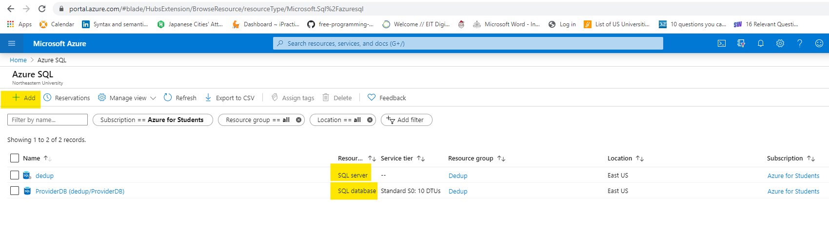  
Create a SQL database: Single database  
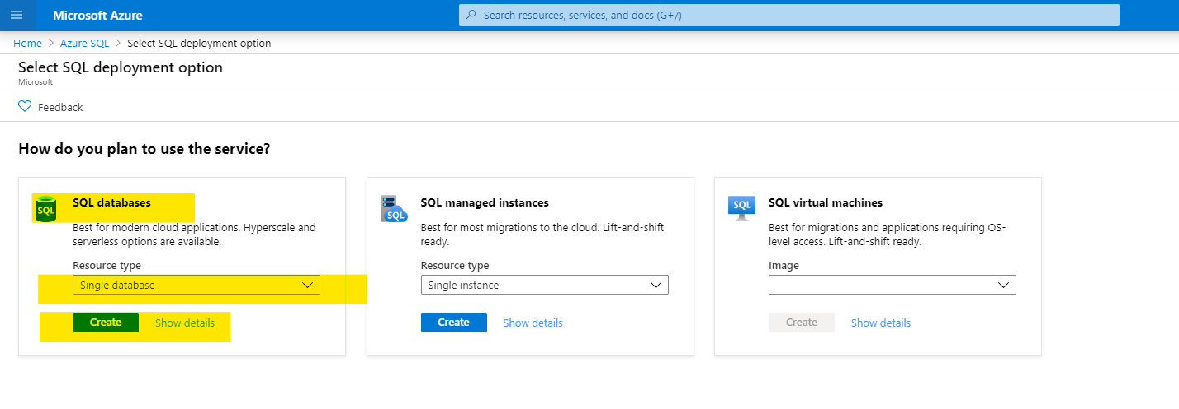  
Enter the required details to create the database:

Create the Server if it isn’t created:

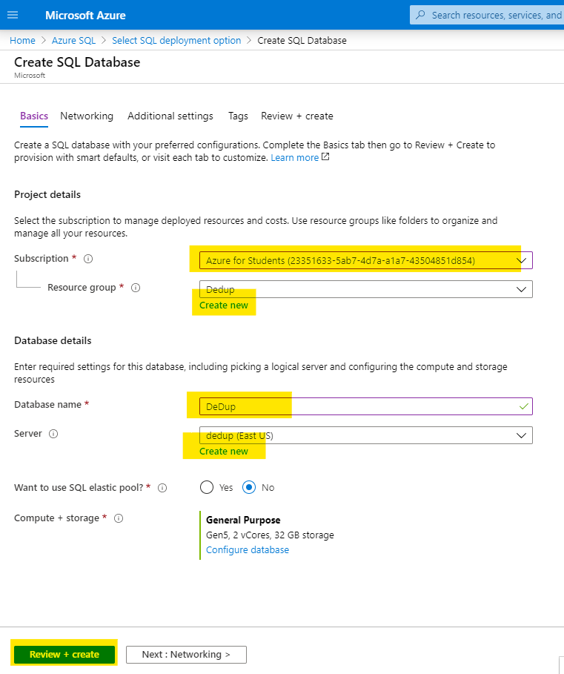

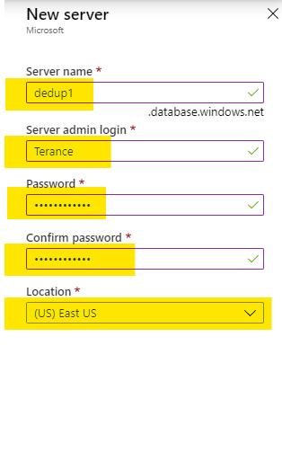

Check the resources and additional resources and create the server.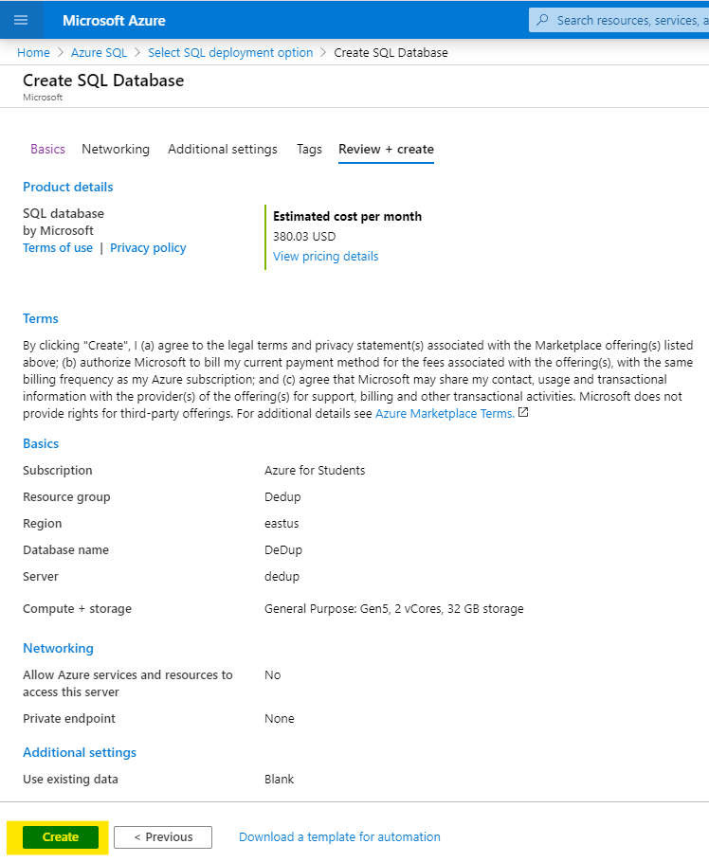

1. Create Azure DevOps  
   
2. Download the files
3. Connect to Azure SQL server database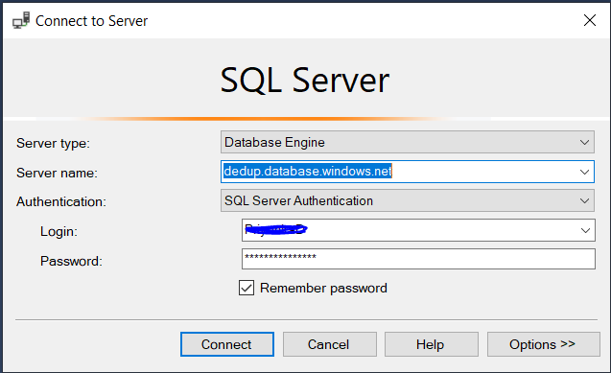
4. Import the file in SSMS into the Storage Schema

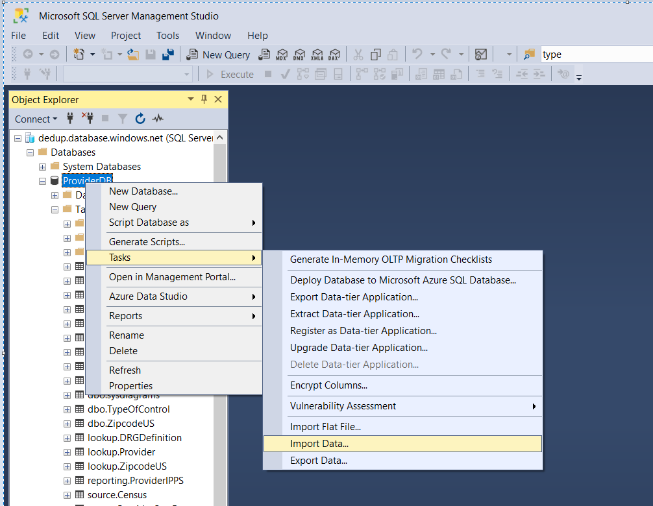

1. Connect to Azure SSIS
2. Make a connection to the Git Repo created via AzureDevOps

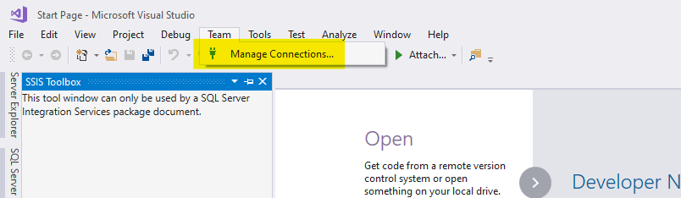

1. Click on manage connection to make a connection to the repo

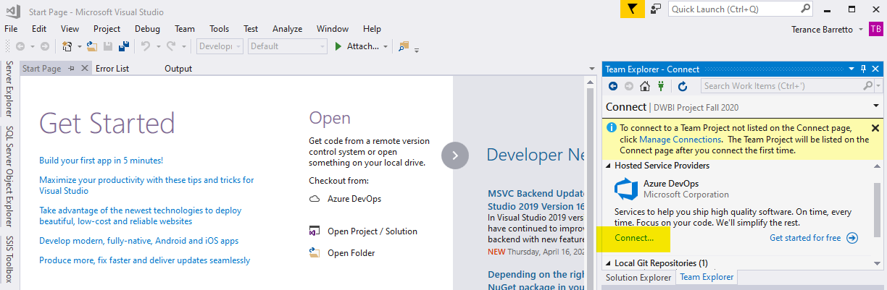

1. Connect to your microsoft account and clone the project repo

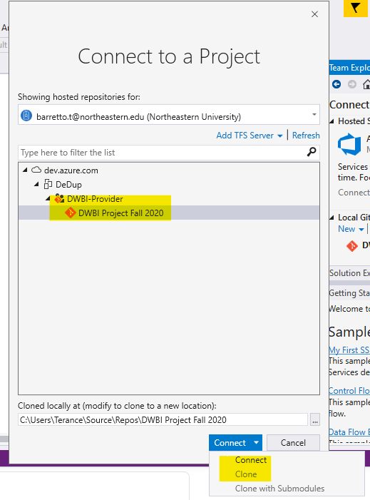

1. Go to the cloned repo location, and open the project file.

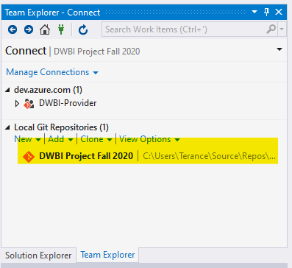

1. Use the “Pull” command to sycn the online repo with the copy on your local machine.

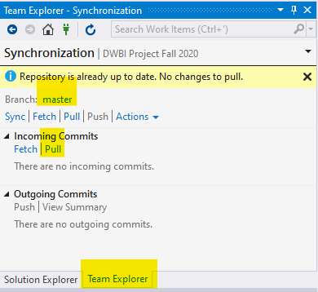

1. Run the container “Load Source Flat Files” in SSIS to load it to Source Table

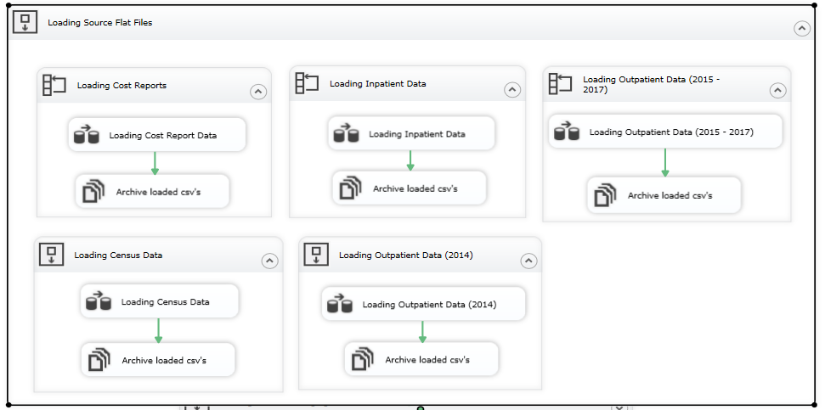

1. Run the container “Loading Data into Staging Tables” in SSIS to load it to Staging table

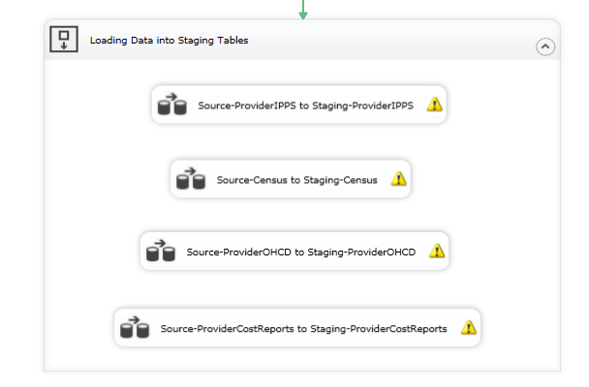

* Provider IPPS (Source to Staging)

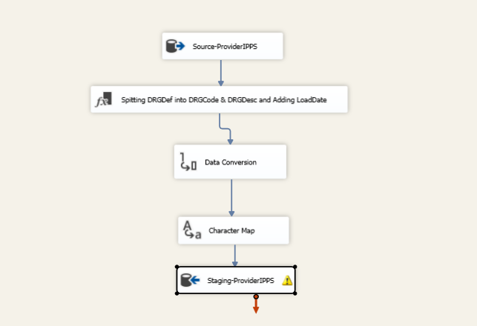

* Census (Source to Staging)

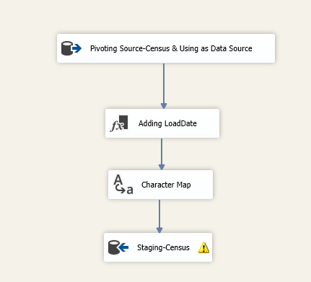

* Provider OHCD (Source to Staging)

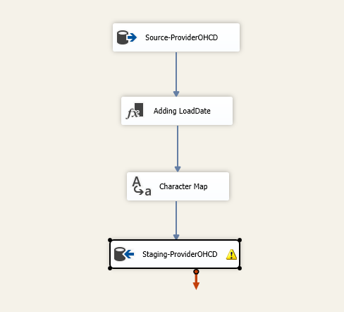

* Provider Cost Reports (Source to Staging)

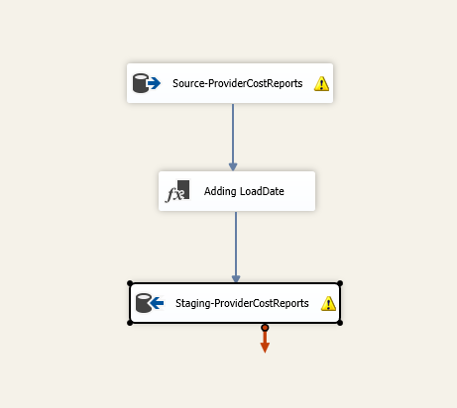

1. Lookup

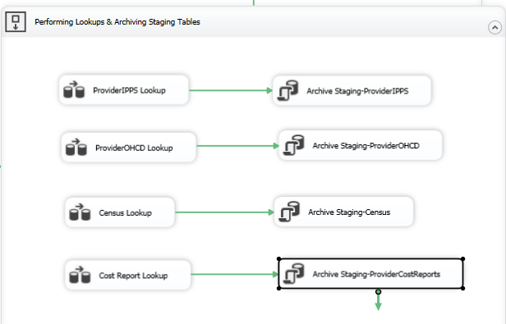

* Provider IPPS Lookup

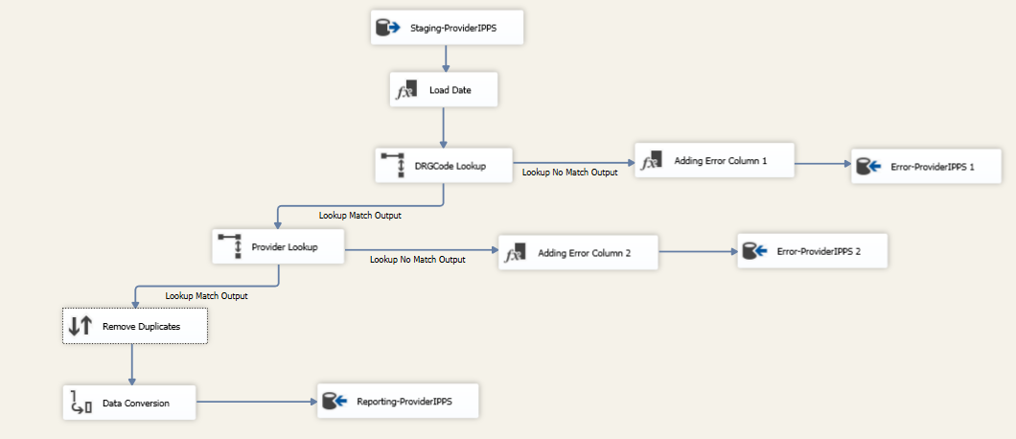

* Provider OHCD Lookup

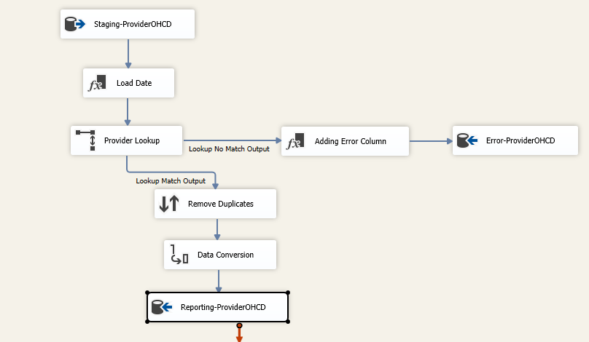

* Provider OHCD Lookup

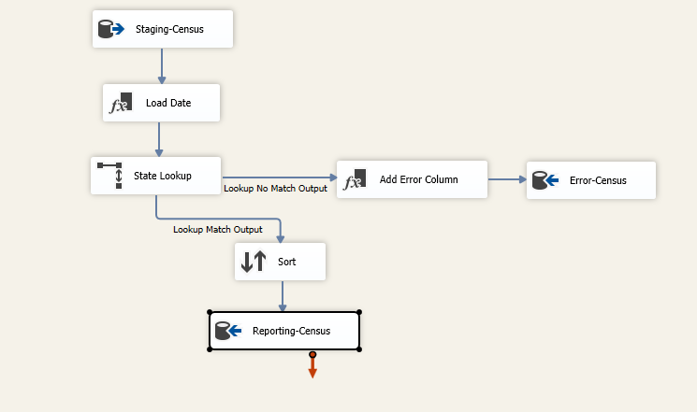

* Provider OHCD Lookup

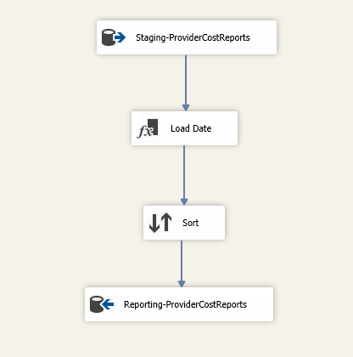

1. Populating Dims and Facts

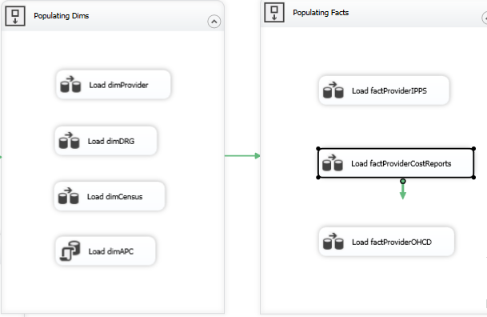

# Observations

Data Cleaning

For data cleaning,we used Talend for data profiling to examine the available data. The key fields from each data source were examined using the Pattern Frequency and Simple Statistics feature of Talend.

* Provider ID

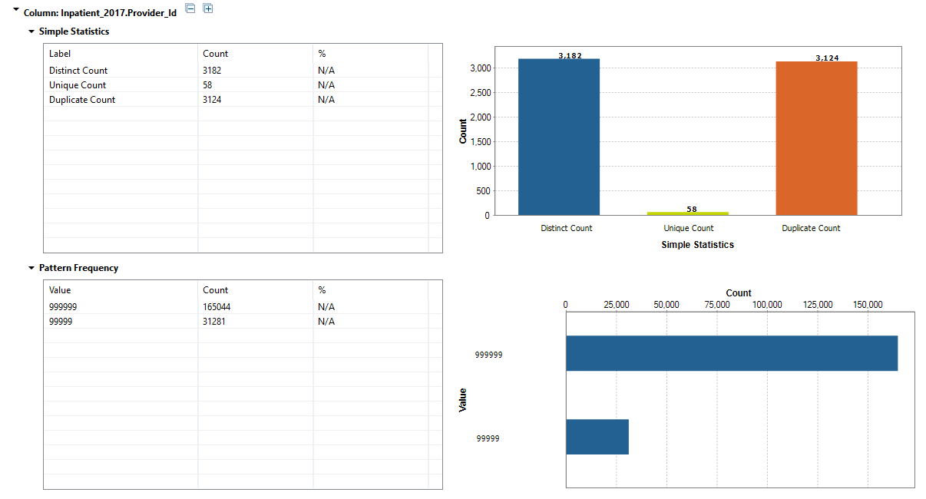

* DRG Definition

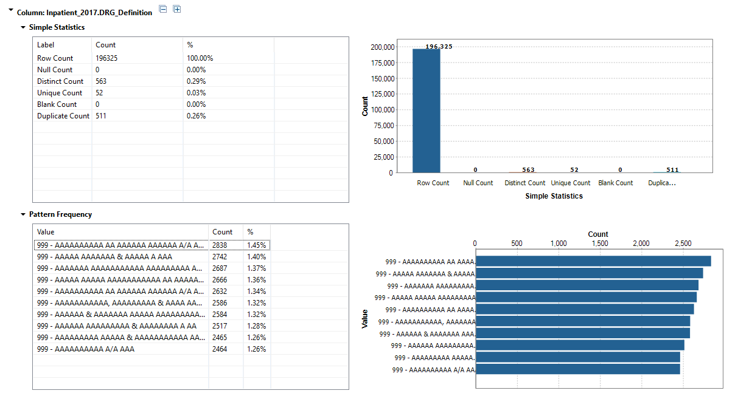

* APC Code

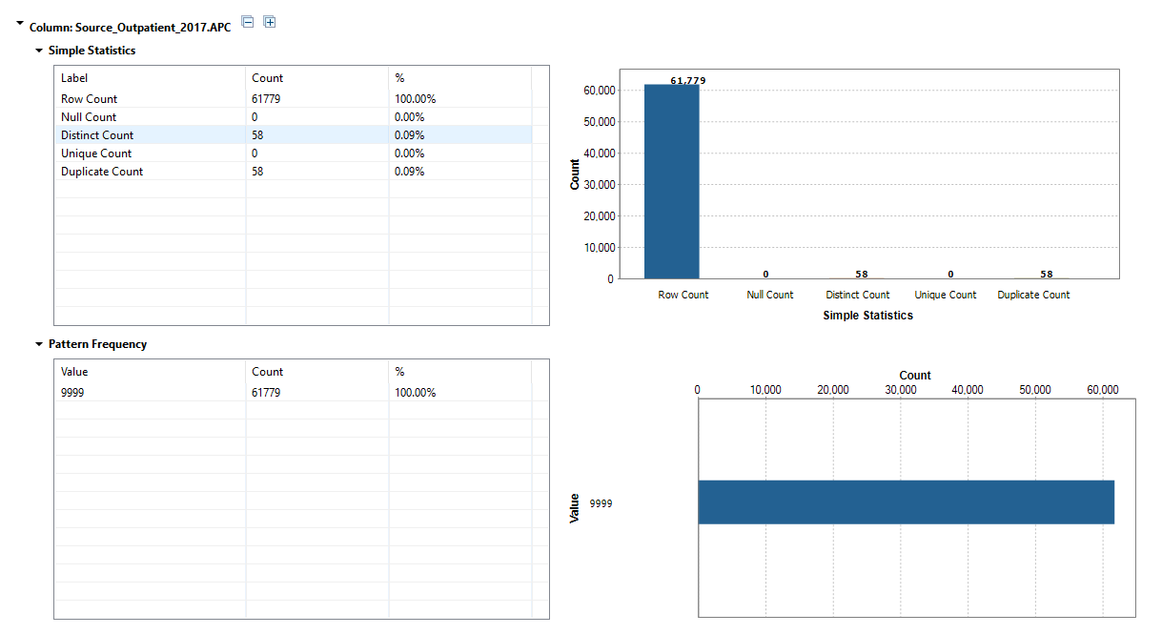

* Zip Code

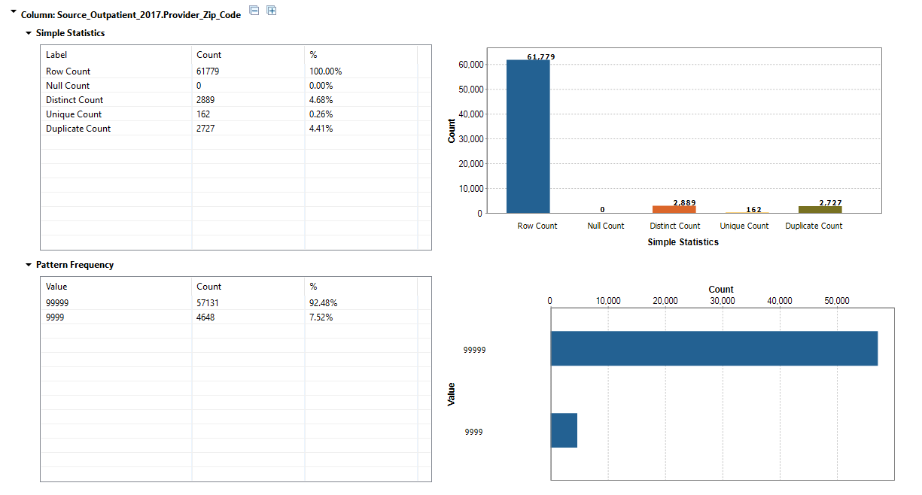

* State Code

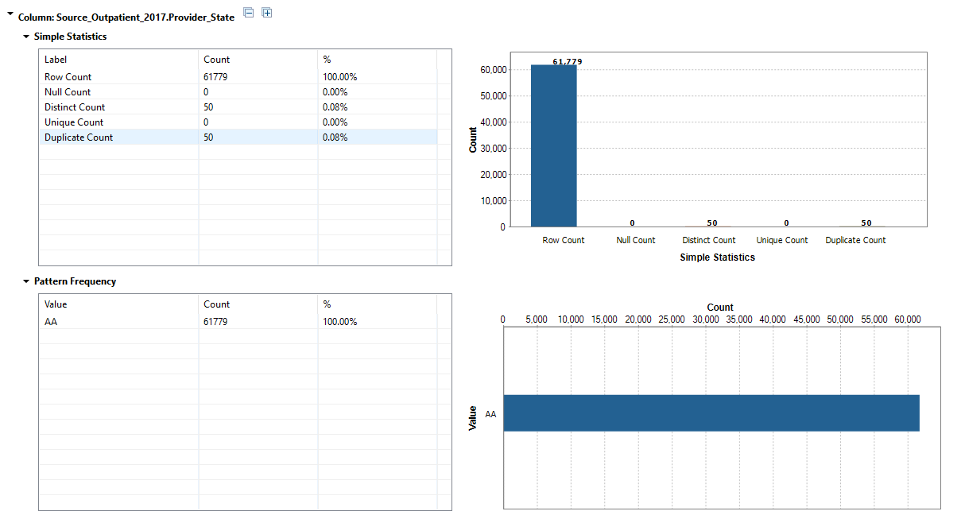

* Apart from this, fields in Provider Cost report required to exclude certain characters such as “$” and “,” to make the data uniform.
* All the character fields were converted to UpperCase
* CamelCase was used as naming convention
* Zip Code, Provider CCN, APCCode and DRGCodes were kept as varchar to maintain data integrity of the codes.

# Visualizations

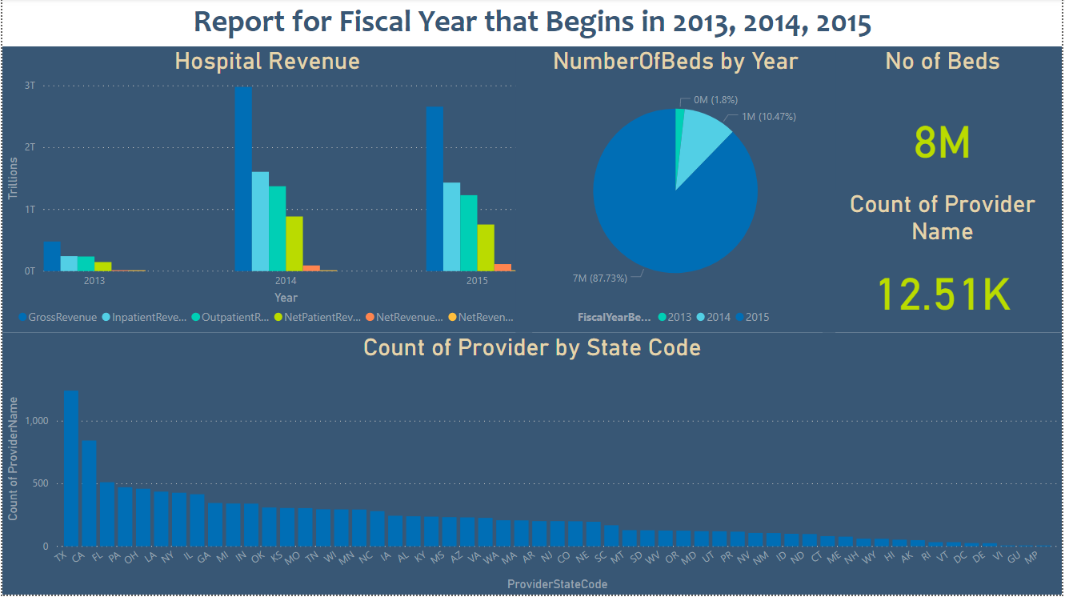

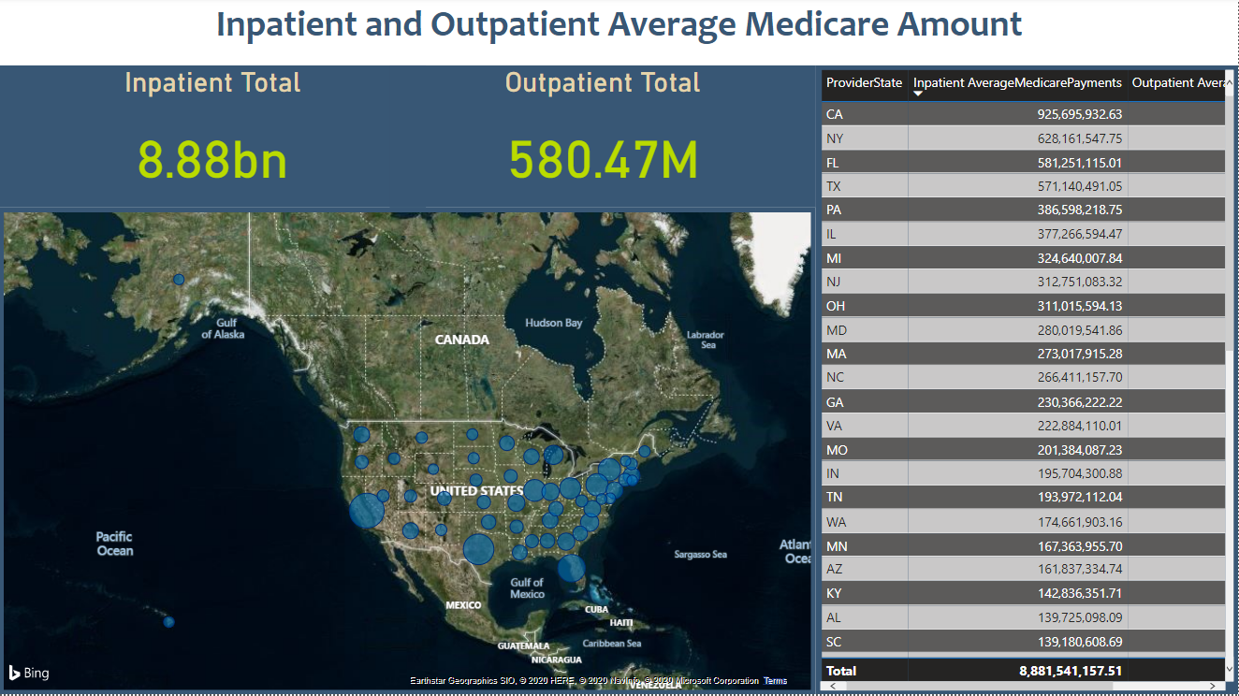

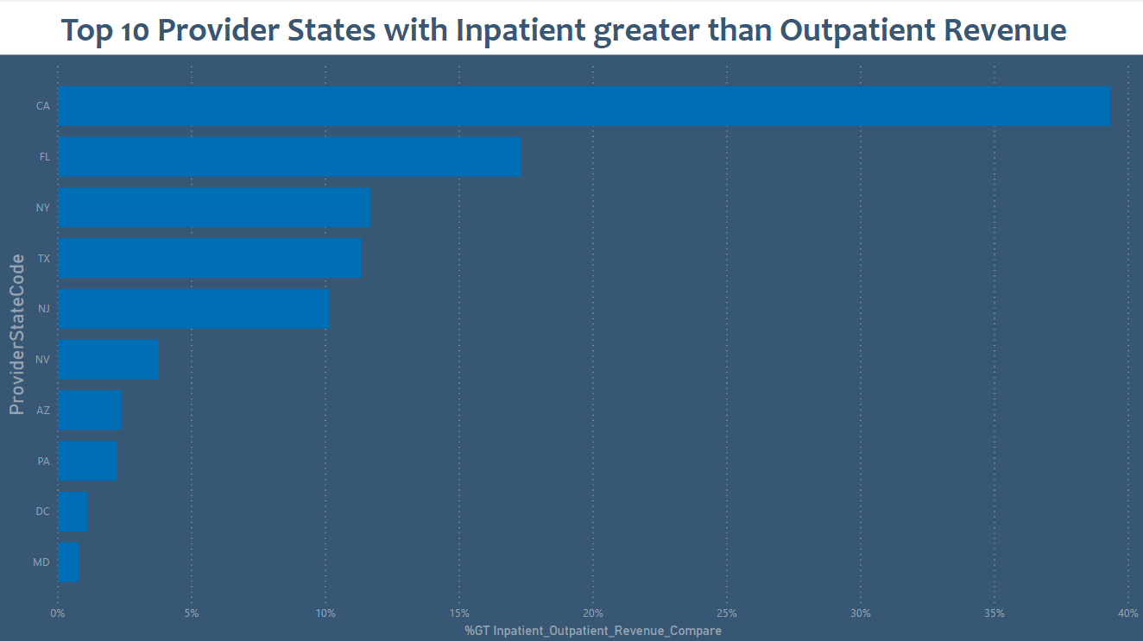

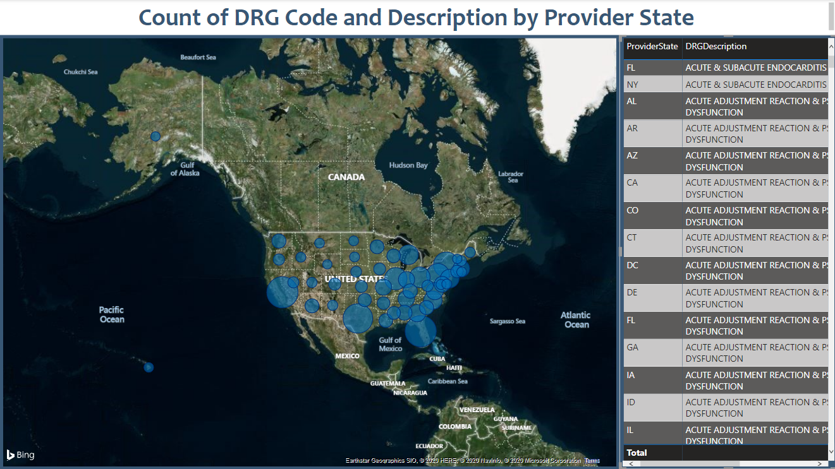

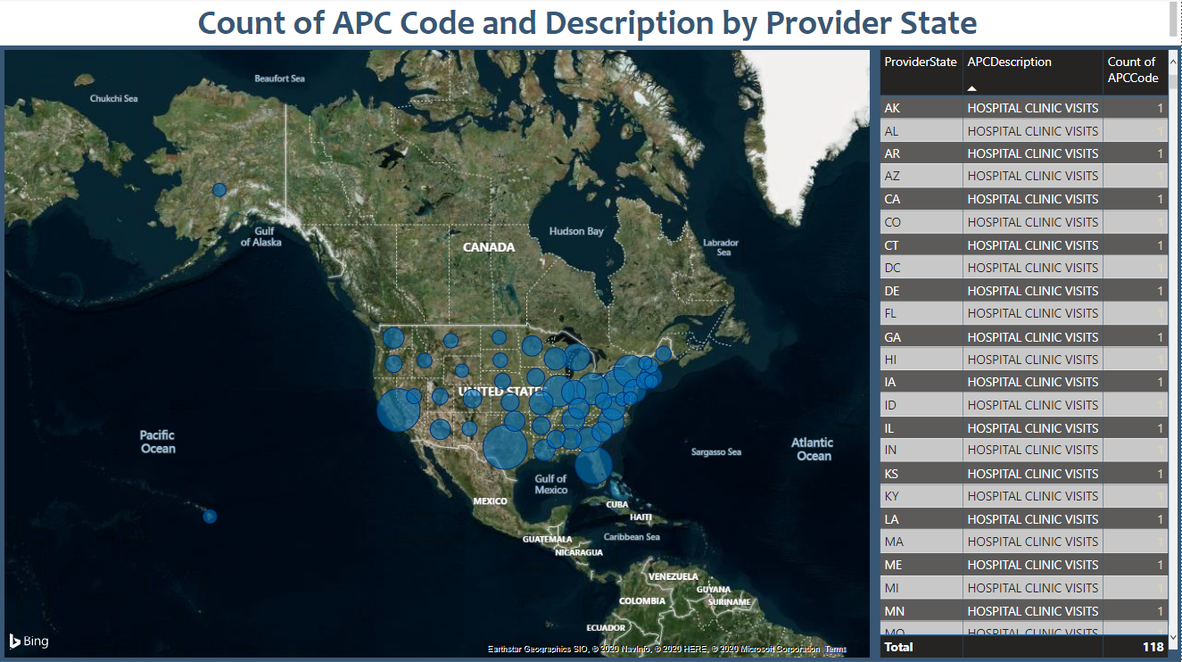

Future Scope

* Move flat file loading completely to cloud to implement all cloud based infrastructure
* Improve dimensional model by adding dimTime and dimGeography